**Deploy Two Static Websites on Kubernetes using NGINX and ConfigMap with NodePort Services**

**Steps:**

kubectl get nodes

mkdir site1

nano site1/index.html

**<!DOCTYPE html>**

**<html>**

**<head><title>Site1</title></head>**

**<body>**

**<h1>Hello Guys this is site1 - Sachin</h1>**

**</body>**

**</html>**

mkdir site2

nano site2/index.html

**<!DOCTYPE html>**

**<html>**

**<head><title>Site2</title></head>**

**<body>**

**<h1>Hello Guys this is site2 - Sachin</h1>**

**</body>**

**</html>**

kubectl create configmap site1-html --from-file=index.html=./site1/index.html

kubectl create configmap site2-html --from-file=index.html=./site2/index.html

kubectl get configmap

nano site1-deployment.yaml

**apiVersion: apps/v1**

**kind: Deployment**

**metadata:**

**name: site1-deployment**

**spec:**

**replicas: 1**

**selector:**

**matchLabels:**

**app: site1**

**template:**

**metadata:**

**labels:**

**app: site1**

**spec:**

**containers:**

**- name: site1**

**image: nginx:alpine**

**volumeMounts:**

**- name: site1-html**

**mountPath: /usr/share/nginx/html**

**volumes:**

**- name: site1-html**

**configMap:**

**name: site1-html**

**---**

**apiVersion: v1**

**kind: Service**

**metadata:**

**name: site1-service**

**spec:**

**type: NodePort**

**selector:**

**app: site1**

**ports:**

**- port: 80**

**targetPort: 80**

**nodePort: 30001**

nano site2-deployment.yaml

**apiVersion: apps/v1**

**kind: Deployment**

**metadata:**

**name: site2-deployment**

**spec:**

**replicas: 1**

**selector:**

**matchLabels:**

**app: site2**

**template:**

**metadata:**

**labels:**

**app: site2**

**spec:**

**containers:**

**- name: site2**

**image: nginx:alpine**

**volumeMounts:**

**- name: site2-html**

**mountPath: /usr/share/nginx/html**

**volumes:**

**- name: site2-html**

**configMap:**

**name: site2-html**

**---**

**apiVersion: v1**

**kind: Service**

**metadata:**

**name: site2-service**

**spec:**

**type: NodePort**

**selector:**

**app: site2**

**ports:**

**- port: 80**

**targetPort: 80**

**nodePort: 30002**

kubectl apply -f site1-deployment.yaml

kubectl apply -f site2-deployment.yaml

kubectl get pods

kubectl get svc

kubectl get nodes -o wide

=>Browser:-

Site1: “http://<Node-IP>:30001”

Site2: “http://<Node-IP>:30002”



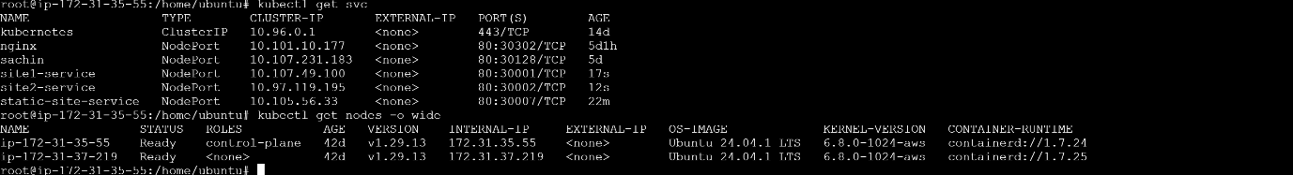

**Site1:-**



**Site2:-**

